**ST. HELENA PRESCHOOL FOR ALL**

The early years are a critical period in a child’s social, emotional, physical, and academic development. In St. Helena and its neighboring communities in northern Napa Valley, there are many excellent, privately-funded preschool programs. But for many families, the high cost of living makes preschool tuition unaffordable. In order to ensure children’s success in school and in life, it is critical that we close the existing opportunity gap as early as possible by providing access to preschool to all families, regardless of their ability to pay.

St. Helena Preschool For All (SHPFA) is a non-profit dedicated to providing opportunities for three and four-year old children to attend preschool. With the support of the St. Helena Unified School District, five private preschool programs and numerous local donors, the program provides scholarships to children from low-income families who would not be able to attend preschool otherwise. To further enrich the preschool experience, all participating families are engaged in ongoing parenting education and hands-on experiences to support their children’s learning and development.

Measuring Program Impact. In 2021, SHPFA undertook a research study to evaluate the short and longer-term impacts of program strategies on children’s academic achievement and social-emotional development, as well as on parent engagement in their children’s education. Using parent survey data, participant demographics and student achievement data provided by St. Helena Unified School District, SHPFA and its evaluation team were able to provide an assessment of the program’s impact on the majority of the children and families served since the program launched in Fall 2010.

Between Fall 2012 and Spring 2021, SHPFA served 114 children, who were primarily Spanish-speaking (88%) Latinos living in low-income households (92%). One of the earliest SHPFA cohort from 2012 is now enrolled in eighth grade, the majority of whom attend at RLS Middle School.

Overall, the positive outcomes and impact of the program serve as strong indicators of SHPFA’s success over the past eleven years.

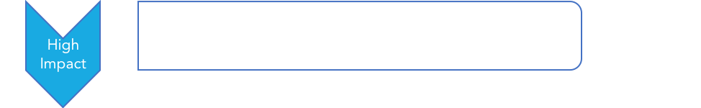Key Finding #1: SHPFA alumni demonstrate strong social-emotional development throughout their school career.

*99% of SHPFA alumni are highly optimistic and happy in school and in life and demonstrate positive peer and family relationships.*

Key Finding #2:SHPFA alumni are active learners with high motivation and willingness to ask for help, two strong predictors of academic success.

*88% of SHPFA alumni are highly motivated in school and 96% are willing to ask for help when they need it. SHPFA alumni maintain their motivation as the progress through school, 83% of older alumni (currently in grades 4-8) remain highly motivated in school.*

**Key Finding #3:** SHPFA alumni parents are confident supporting their child’s learning.

*100% of alumni parents report feeling very or fairly confident supporting their child’s learning. Parents’ confidence is further evidence by the fact that 86% have engaged with their child’s teachers in the last year to monitor and encourage their student’s progress.*

**Key Finding #4:** SHPFA alumni parents are highly engaged in their children’s education.

*****100% of alumni parents report active engagement in their children’s schools over the past two years. 94% have attended key parent events and 70% report engaging with their child’s education in at least three different ways. Alumni parents maintain their engagement as their children move through the school system: 87% of parents with children currently enrolled in grades 4-8 volunteer at school and 67% have participated in school in three or more ways during the last two years.*

**Key Finding #5:** SHPFA alumni demonstrate lower academic achievement but higher growth than their peers.

*About half of SHPFA alumni scored Low/Low Average on Reading (48%) and Math (55%) assessments, compared to 33% and 44% of their peers, respectively. In both Reading and Math, SHPFA alumni demonstrated stronger growth than their peers, with average student RIT scores of 188 in Reading and 190 in Math, compared to their peers whose average RIT scores were 185 and 188 respectively. However, given the challenges of distance learning and limited instruction, learners across all student groups did not advance their skills at the rate of a normal school year.*

**Key Finding #6:** SHPFA alumni are well equipped to attain fluency in English.

*Most (88%) of SHPFA alumni come from Spanish-speaking homes but also demonstrate strong English language skills. Of all Spanish-speaking alumni, 18% arrived at Kindergarten fluent in English and 24% have been reclassified as English proficient. Of those SHPFA alumni currently classified as English Learners, 74% are approaching proficiency with Levels 3 and 4 ELPAC scores.*

**Conclusion.** While the data available does not support a direct connection between program participation and measurable gains in academic achievement, it does indicate that SHPFA alumni are engaged learners who begin school with foundational English Language skills that allow them to move quickly towards fluency. SHPFA alumni demonstrate high levels of motivation and social-emotional skills throughout their school experience.

Just as importantly, SHPFA alumni parents gain skills and experiences through the program that support long-term engagement in their child’s education. For Latinx students, parent engagement in school is critical for supporting the academic motivation and perseverance that allow them to grow and achieve.